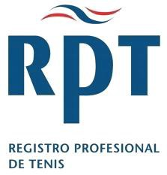

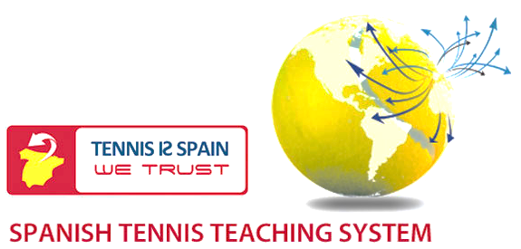

LEVEL 1 and LEVEL 2
INTEGRAL COURSE

A unique and exclusive opportunity to gain International Qualifications
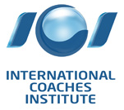

LEARN TO COACH THE SPANISH WAY

BACKGROUND

The RPT was founded and developed in Spain and has now trained more than 50,000 coaches worldwide in the past 25 years. The success of Spanish Tennis over this period of time is unparalleled and it is on this success that the teaching methods and systems of the RPT are based. Spain has not just produced a world-class player "every so often" but consistently over the years and this can only be done if there is a solid coaching programme throughout the country and a system that allows these coaches to develop their own players.

The RPT is integral to this system in Spain, in fact all the private Tennis Academies in Spain use RPT coaches including Sanchez-Casal Academy and the Ferrero Academy, 19 of Spain’s top 20 players are trained by RPT coaches including Tony Nadal, coach to Rafael Nadal, Antonio Cascales coach to Juan Carlos Ferrero and Davis Cup Captain Emilio Sanchez- Vicario. With this background and this success it is not surprising that the RPT is the fastest growing coaching organization in the world today.

The new RPT Level 1 course is designed to open doors in the career of teaching tennis for coaches who wish to start working full or part time with mini-tennis players and beginners, teachers or coaches who want to improve or expand their knowledge, and for players want to know the basics of teaching and improve their own performance. To participate is the course the minimum age is 16 years old.

The Basic Education System RPT has been completely renovated with a new educational application: tetafime which consists of 4 pillars: physical, technical, tactical, physical and mental, which have been joined, intertwined and interconnected so that any individual can achieve their Ideal Performance State.

LEVEL 1 & 2 INTEGRAL COURSE

The RPT Integral course lasts for three days, using four components, with five areas of performance and a series of tools for their development and implementation, among which are:

COACH DEVELOPMENT | PLAYER DEVELOPMENT
COMPONENTS
TECHNICAL
Professional capacity | Benchmarks
Personal Image | Mechanical Strength
Using media | Progressions
Facilities | Demonstrations
Work ethic | Drills and Practice
TACTICAL
Planning | Priorities
Teaching | Set Plays
Philosophy | Percentage Tennis
Preparation | Player controls point
Service | Opponent controls point
PHYSICAL
Performance and Energy | Footwork
Nutrition | Balance
Hydration | Force
Equipment | Recovery
Fitness Levels | Fitness Levels
MENTAL
Passion | Environment
Motivation | Emotional Control
Discipline | Rituals
Commitment | Physical Response
Attitude | Reinforcement
PROGRAMME OUTLINE

The RPT Integral course develops the lesson in a 6 block structure, involving four components, with 5 zones of performance, and the tools for its implementation, with the following structure:
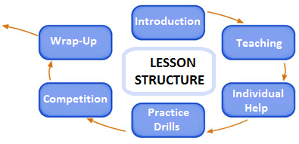
At the end of the course, all coaches who have completed the course, the assessments are eligible to receive the qualification of International Professional Tennis Registry the International Coaches Institute and the European Union at one of the following levels:-
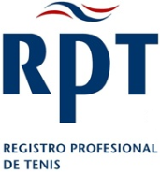
INTERNATIONAL QUALIFICATIONS
European Professional
National Professional
Instructor 1
Instructor 2
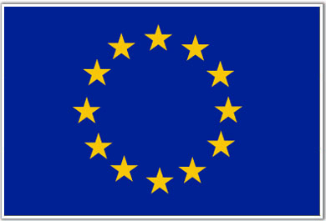

European Union Supplementary Certificate

The tests are divided into 3 parts: Written, Teaching and Skills. The written exam consists of a series of multiple choice and short answer questions. For the teaching element coaches will be continually assessed on their coaching, organisation and communication skills and their technical knowledge. In the skills element coaches must show their ability to demonstrate the key strokes and to feed effectively.

Coaches will receive a grade for each element of the test and the lowest of the 3 grades will become the coaches’ final grade.

TESTIMONIAL
“The RPT was the first organisation to recognise the work being carried out with my nephew Rafael. Their influence in the training of coaches and development of tennis is Spain is very important”. Tony Nadal. Coach to Rafael Nadal World #1
FOR FURTHER DETAILS CONTACT
www.love4tennis.pl ; www.kortymacieja.pl

